SPI: Notice on changing seal of the Company
On 22/01/2018, Stone Company Spilit Joint Stock Company noticed on changing seal as follows:
- Seal mode:
Old seal New seal
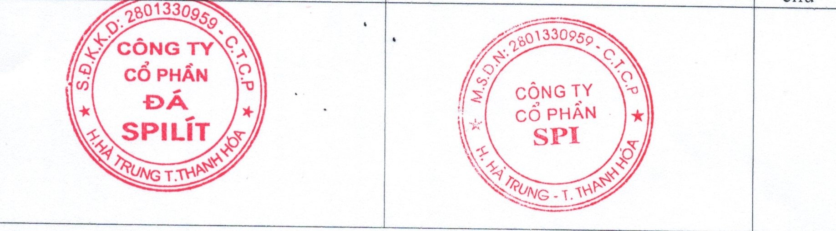
- Number of seal
- Number of seal before change: 01 seal
- Number of seal after change: 02 seals
- Validity: 22/01/2018

